Search

David Murphy
27 June Growth

3 Easy Ways To Improve Your Restaurant’s App

Restaurant apps are notorious for frozen payment transactions and horrific user accessibility. It's a shame, because a recent survey shows that 46% of users report that apps/websites with easier navigation would make them feel more comfortable with finishing a payment transaction.

In 2015, total app revenue amounted to a total of 89.17 billion dollars. How can your business tap into that wealth? Better yet, if your business has an app, is user accessibility the sole determinant for its poor performance?

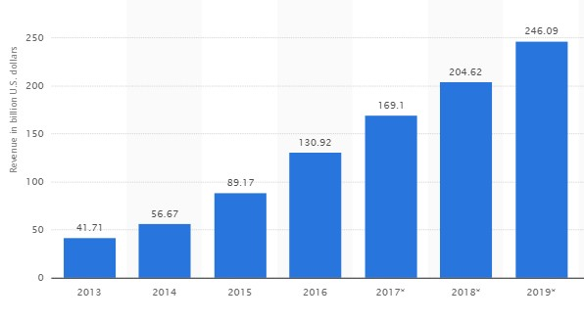

The truth is, not many restaurant apps are successful, but the most recent statistics pulled from the Jumio 2015 Survey is helping

us understand why. Two years prior in 2013, the same study was made, which posited that 66% of respondents had failed to complete a transaction due to issues during the checkout process.

Evidence from the more recent follow­up study in 2015 foreshadows a rising potential for commercial apps, as the number of failed transactions has decreased from 66% to 56% in just two years. Behind general retail, transactions regarding food and travel have been among the most frequently abandoned, but the problem is not necessarily grounded in the nature of food and travel apps.
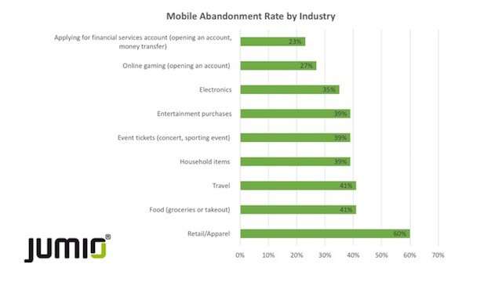

The issue can be broken down into three main causes, ordered below from the most prevalent to the least among users in the Jumio

2015 survey:

1. Slow loading times

“The loading bar’s frozen…What now? Does that mean my order never went through?”

36% of users cited slow loading speeds as the cause for abandoning mobile transactions.

Based on the feedback gathered from respondents in the Jumio 2013 Survey, nearly two­thirds (66%) of consumers attempting to make a transaction on their smartphone or tablet were forced to abandon their purchase:

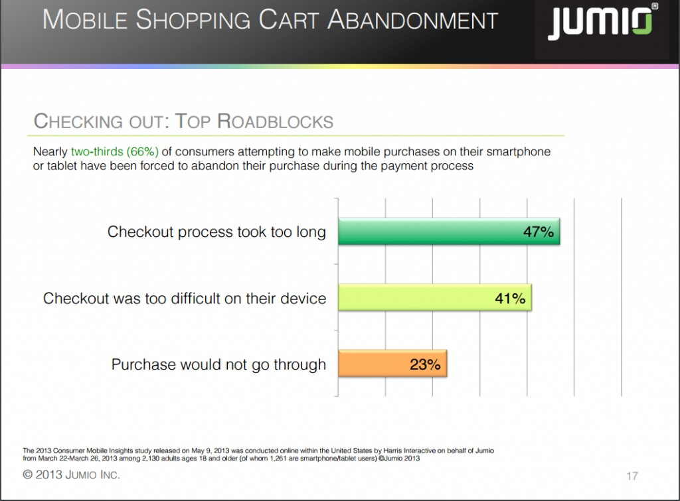

The heightened competition across the app store leaves users with more reasons to leave your app than to remain loyal to it. Why should anyone struggle with a slow app when a faster one that promises to match the same function more consistency is available to them at the same price? The same notion applies to using an app over using a desktop: why should someone use an app for a service that’s faster on the web via their desktop?

The point of your restaurant’s app should be to provide a faster and more convenient method than calling­in or using your website, which is a good introduction to the next point ­ user experience.

2. User experience

“How do I even place an order on this thing?”

31% reported that apps/mobile sites that are too difficult to navigate

28% responded that it is difficult to type personal information on small screen

22% reported that the payment process was too complicated

Overall, 46% of users agree that apps that are accessible and easier to navigate would make them more likely to complete a payment transaction. The more difficult it is to make a transaction, the less likely users are to convert into paying customers. Your intention should be to mitigate the number of hurdles facing users before they can complete transactions, and the gathered data above affirms this notion.
3. Security concerns

“Their app doesn’t seem too official, I mean it’s very unresponsive and navigation isn’t user­friendly whatsoever...Maybe I

downloaded the wrong app?”

27% reported concerns around security of payment info

26% reported concerns around security of personal info

Although security and comfort contributed least to users' decisions, you can see how both an app’s responsiveness and its ease­of­use contribute to a user’s expectations and their overall sense of trust with the app. During the Jumio 2013 survey, 51% of users that abandoned an online transaction did so because they felt “uncomfortable entering their credit card information.”

62% of respondents aged 55+ felt uncomfortable with the service they were using

59% of respondents aged 45­54

45% of respondents aged 18­34

The ideal app should cater to and be easy­to­use for a sizable margin of users with a wide age group in mind.

0
You might also like this articles

Dominick Wojtas
15 July

Messapps Named a Top NYC App
Development Firm

Recently, we were named as a

by Clutch, a research firm with the most expansive research coverage on mobile app development agencies. Over twenty five app development agencies were included in Clutch’s research with our team topping the chart!

0
David Murphy
20 June

The Mobile App Businses Model Made
Simple

The obscurity behind the term “business model” oftentimes causes uncertainty and confusion. For our purposes, lets think of it as a birds eye view of how your business will operate.

0

